SQL Server Integration Services

# Module 03: Projects vs Packages

1. Launch SQL Server Data Tools (SSDT), under start menu look for Visual Studio 2017 (SSDT).
2. In the Start Page, click Create new project.  
   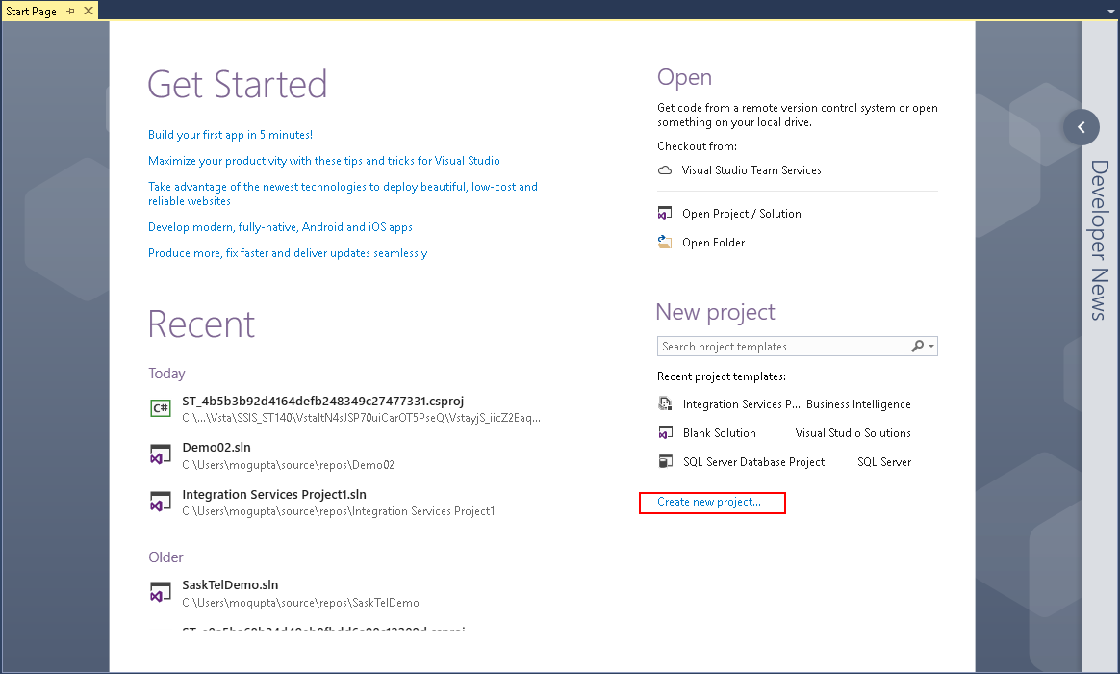
3. In New Project dialog box select Business Intelligence > Integration Services > Integration Services Project. On the bottom enter in project name and location you wish to save the project. Make sure “Create directory for solution” is selected and click OK.

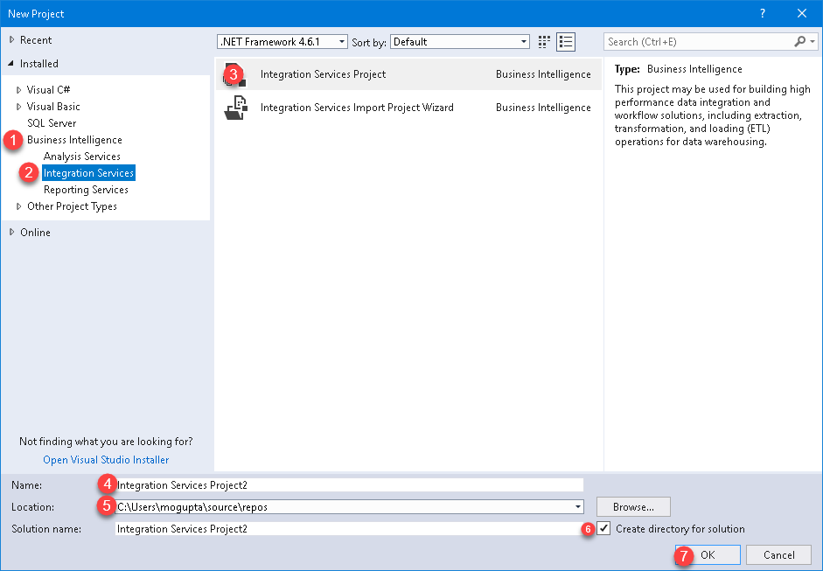

1. Let’s set up a connection manager to our database. In the bottom center pain under Connection Manger, right-click select New Ole-DB Connection.  
   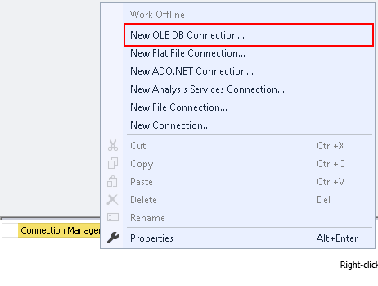
2. In Configure OLE DB Connect Manager, click New.  
   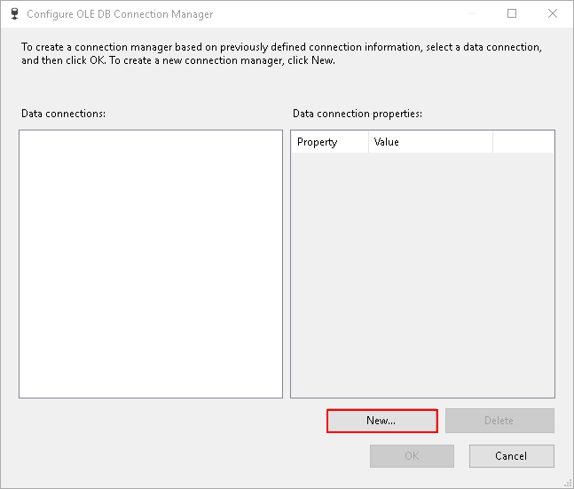
3. In connection manager, type the server name, select the database “AdventureWorks2012” and click OK.  
   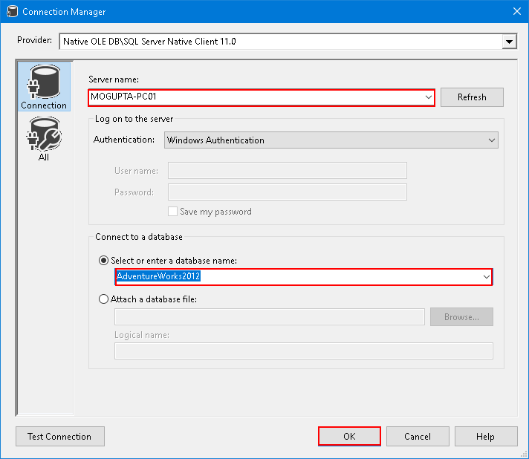
4. Click OK in Configure OLE DB Connection Manager. You should see a single connection under Connection Manager.  
     
   *Hint: Rename the connection manager to OLEDB.ServerName.DatabaseName. This will make it easier to identify which driver is being used for the driver.*
5. Create a new task, Execute SQL Task.

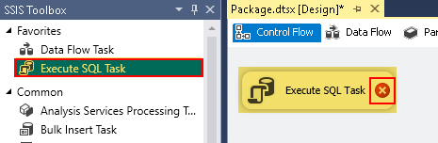

1. Again the alert shows we are missing configuration. Double-click on the task to finish the configuration. Configuration items required are **Connection** and **SQLStatement**.
2. Click on the drop-down by connections, notice the connection we created in step #7 is present. So select OLEDB.ServerName.DatabaseName.  
   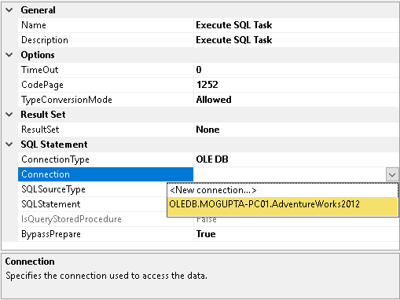
3. In the SQL Statement enter “SELECT @@ServerName” and click OK.
4. Execute package to confirm no issues, you should get executed successfully with green checkbox. Click on red stop button to go back to development.
5. Let’s add a second package to the project. Right click on SSIS Packages > New SSIS Package. This should create a new package like below.  
   
6. Lets create a task again, Execute SQL Task.

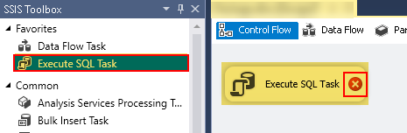

1. Like before we have an alert because we are missing configuration. Double-click to configure Connection and SQLStatement.
2. However, when you click on the drop-down, note our connection created earlier is not present.  
   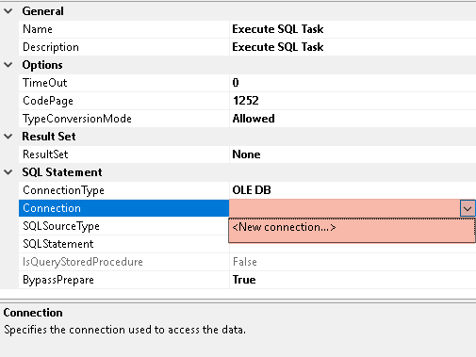
3. This is because connection was created in first package and is scoped to that package only. What we need is a project connection. But since we already have a connection, lets reuse it from the first project. Click cancel in “Execute SQL Task Editor” dialog box.
4. Go to the first package. Right-click on connection OLEDB.Servername.DatabaseName and select Convert to Project Connection.

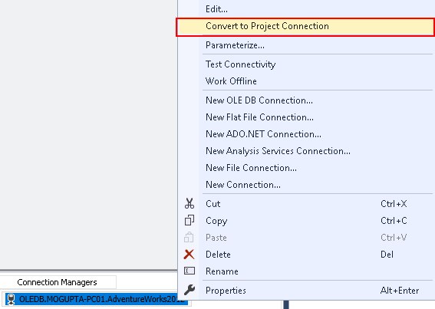

1. Note the connection name has (Project) in front of it and shows up under Connection Manager under Solution Explorer.
2. Let’s go back to second package and finish our task configuration.
3. This time you should see the connection under connections.
4. For SQLStatement enter “SELECT @@ServerName”.